ĐỀ CƯƠNG ÔN TẬP THI LẠI ANH VĂN 8 (2019-2020)
SAMPLE TEST 1
- Choose the word or phrase (A,B,C,D) that best fit the blank space in each sentence (3ms)
1. I am delighted_____you passed your exam.
a. that b. to c. in order to d. so that
2.A:I'm thirsty. Will you pour a glass of water for me?
B: ______________.
a.Of course b. Thanks c. I’m sorry d. No, I’m not
3. _____is a wonderful natural fertilizer.
a. Compost b. Plastic c. Envelope d. Garbage
4. Please try_____ quiet when you come home. Everyone will be asleep.
a. be b. to be c. being d. to being
5. Is the rubbish______ every day?
a. collect b. collecting c. collected d. be collected
6. _____ is a chair with wheels for somebody who cannot walk.
a. Stretcher b. Ambulance c. Wheelchair d. Crutch
7. It is_____ to park in the center of Newton.
a. impossible b. impossibility c. impossibilities d. impossibly
8. Let’s play tennis instead __________ watching television.
a. on b. in c. off d. of
9. ______ the door, please?
a. Will you shut b. Do you shut c. Are you shutting d. Are you going to shut
10.She covered her knees______ a blanket.
a. in b. under c. with d. of
11. The picture advises us:
a. To use more water.  b. Not to waste water.  c. To turn off the tap after using  d. To wash our hands before eating. | 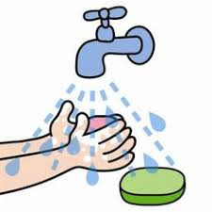
12. The picture says that:
a. We must protect our planet.  b. The Earth is very beautiful.  c. The Earth is a planet.  d. The Earth is the largest planet. | 

II. Use the correct form of the verb or word given in each sentences (1.5 ms)
13. She was for days after the accident. (conscious)
14.These products are friendly. (environment)
15.The of water caused the dam to burst. (press)
16. Companies are encouraging people to buy more by .............................. the prices of their products. (reduce)
17. She is very about her mother's health. (anxiety)
18. Reduce means not buying products which are . (over package)
III.Rearrange the groups of words in a correct order to make complete sentences (0.5m)
- Could/ give /mom/you/ an/me/ aspirin, ?
..........................................................................................................
- Compost/ made/waste /household/ garden/ from /is/and.
..........................................................................................................................
IV. Choose the word (A, B, C or D) that best fits the blank space in the following passage (1.5ms)
Yesterday, when I was riding along a busy street, I saw an (21)______. A woman was knocked down when she crossed the street at a zebra crossing. Many people stopped to offer their help. A police man arrived and asked a young man to telephone for an ambulance. While waiting for the ambulance, the policeman and some people tried to (22)_____the bleeding. They used a handkerchief to cover the wound, then put pressure (23)_________it and held it (24)_______They tried to talk to her (25)____________ keep her (26)_________After about three minutes, the ambulance arrived and the woman was taken to the hospital.
21. a. accident b. event c. ambulance d. emergency
22. a. cut b. hold c. stop d. cover
23. a. off b. on c. in d. forward
24. a. tight b. tightly c. tightness d. tights
25. a.in order to b. so c. therefore d. in addition
26. a. awake b. unconscious c. asleep d. warm
V. Read the following letter. Decide if the statements from 27 to 30 are True or False and choose the correct
answer (A, B, C or D) for the questions 31 and 32 (1.5ms)
Earth Day is coming! Our class are going to celebrate it by making crafts from used materials in the recycle-reuse-renew lessons. We also buy some brand-new craft supplies to celebrate and learn about Earth Day. We start by looking for old things around our houses and bring them to class. Today, we learn how to make a hanging garden with plastic bottles. Large plastic bottles are turned into beautiful hanging planters in this green-living and green-thumb project. They are easy to make. All we have to do is to cut one side of the bottles so that we can put soil and plant small flowers in them. We can either bring the planters home or hang them on campus for a gorgeous hanging garden.
27. It’s about time to celebrate Earth Day. ______________
28. The writer’s class are going to have the recycle-reuse-renew lessons. ______________
29.They don’t need any new craft supplies. ______________
30.Today their class use plastic bottles to make flower vase. _______________
31. What are they going to celebrate when Earth Day is coming?
A.They celebrate a party. C. They draw a lot of pictures to encourage people to use energy economically.
B. They plant trees along the street. D. They make crafts from used materials.
32. How do they do with plastic bottles?
A. They cut them one side. C. They put soil on it.
B. They use them to plant small flowers. D. All the correct.
VI. Rewrite the sentences without changing meaning (2 ms)
33.Many people in the world speak English.
English.......................................................................................................
- Working in those conditions is impossible.
It’s.............................................................................................................
35.He climbed the tree because he wanted to get a better view.
He climbed the tree so as...........................................................................
36. ‘Please send an ambulance to Quang Trung School,’ Lan said to the nurse.
Lan asked....................................................................................................
SAMPLE TEST 2
- Choose the word or phrase (A,B,C,D) that best fit the blank space in each sentence (3ms)
1. ______ is a large hole in the side of a mountain or under the ground.
a. Waterfall b. Cave c. Bay d. Lake
2.Before______ for work, I ate breakfast.
a. leave b. leaving c. to leave d. left
3. Do you mind_____ I leave early?
a. if b. when c. that d. 0
4. The house _____ on the hill started slipping.
a. build b. builds c. building d. built
5.The council should be able to help families who have no accommodation.
a. a place to live b. a place to watch sport matches
c. a place to buy meal and eat it d. a place to work
6..Will you pick me _____ after the party?
a. on b. over c. through d. up
7.A cup of tea sounds______ .
a. perfect b. perfectly c. perfection d. perfectionist
8. ___________ I was a child, I was always kicking my ball through the window.
a.when b.while c.as d. since
9.A:How was the trip?
B:_________________________
a. It was terrible. b. It was awful. c. It was great. d. a & b are correct
10.Tom burnt his hand when he _____ the dinner.
a. cooked b. was cooking c. has cooked d. cooks
11. The picture says that:
a. We mustn’t swim here.  b. We must protect the ocean.  c. We can swim here.  d. We can’t go fishing here. | 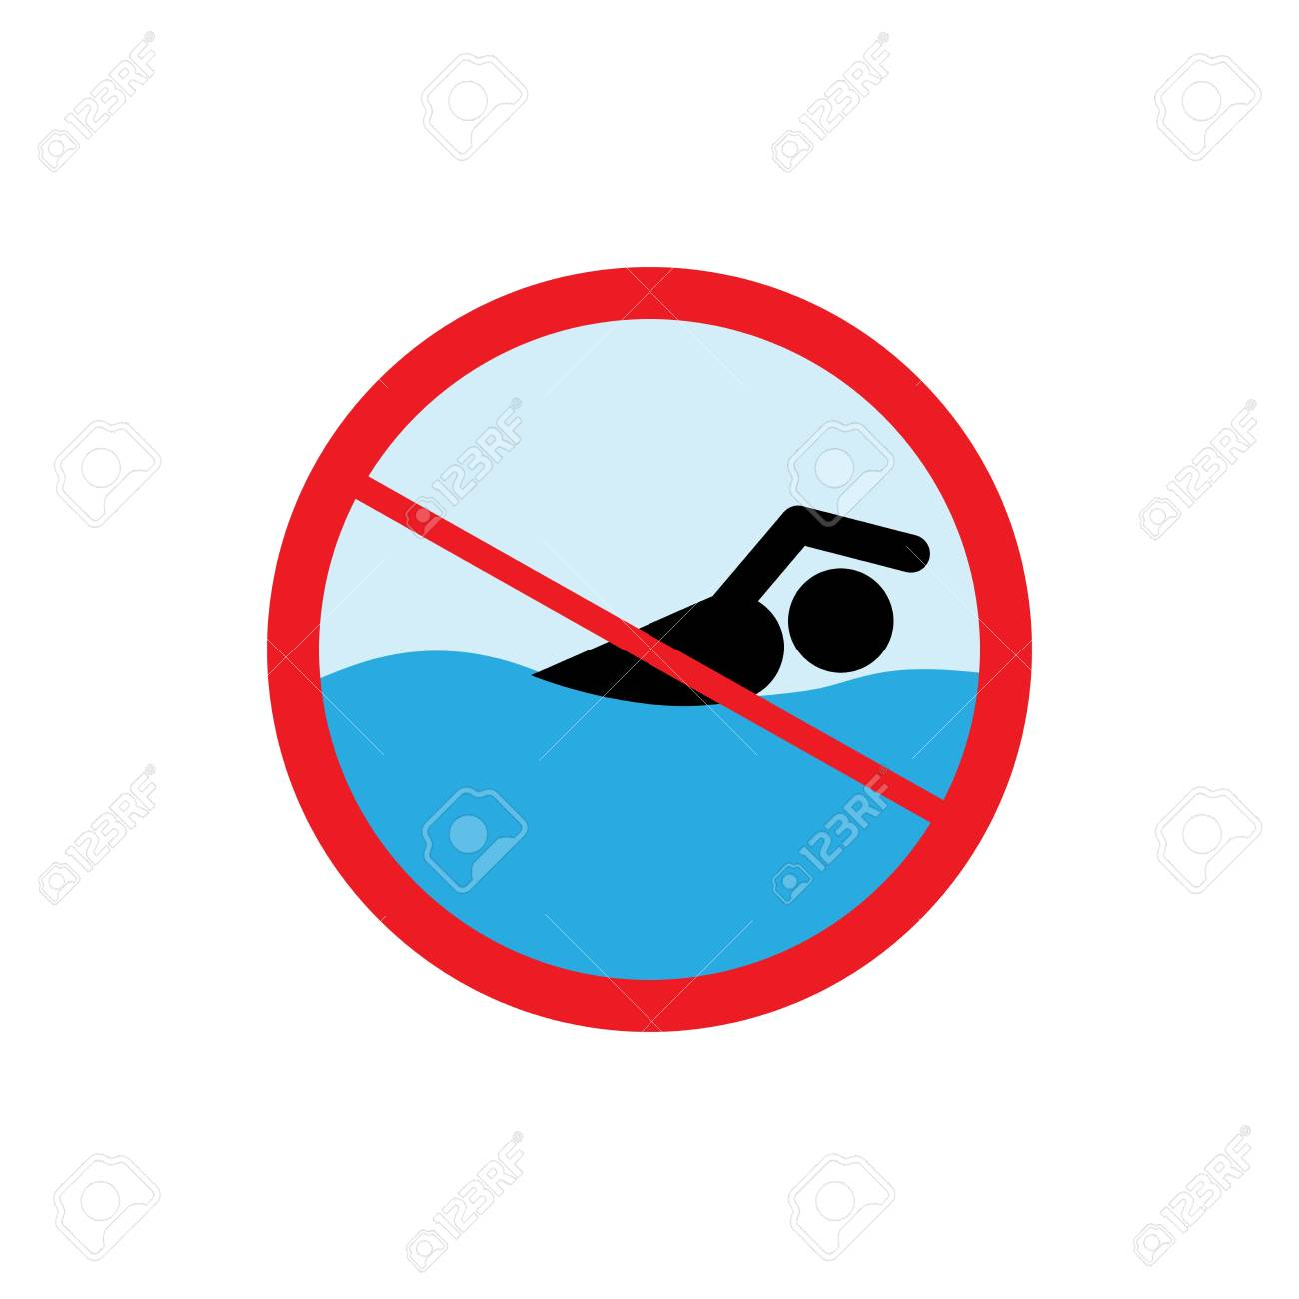
12. The picture says that:
a. We shouldn’t go fishing here.  b. A fish can bring a lot of things.  c. A whale is dangerous.  d. We must protect the ocean. | 

II. Use the correct form of the verb or word given in each sentences (1.5 ms)
13.Every week, there are two from Hanoi to Nha Trang. (ﬂy)
14.There are fights ............................... from Ho Chi Minh City to Nha Trang. (day)
15. He received the award in ...........................................of his success over the past year. (recognize).
16................................. , her illness was more serious than we thought. (fortunate)
17.It is ...................................... that your European friends can easily eat with chopsticks. (surprise)
18.It was a great vacation. The food was good and the .....................................was excellent. (accommodate)

- Rearrange the groups of words in a correct order to make complete sentences (0.5m)
- Can/ information,/me/please/you/ some/give?
..............................................................................................................................
- Thanh/ always/ complaining / heaviness /of /my/ the /suitcase/ is/ about/.
...............................................................................................................................
- Choose the word (A, B, C or D) that best fits the blank space in the following passage (1.5ms)
I have always wanted (21) _____ fishing. On the last day of my vacation, I went fishing on a beautiful lake. (22) _____, I didn’t catch any fish, and I got (23)_____. I decided (24) _____ swimming. When I stood up, (25)_____wallet fell out of my pocket, and into the water. It had all my money, my passport, my plane tickets - everything. I jumped into the lake to look (26)____it, but I didn’t find anything. I have never had such a terrible experience.
21. a. go b. to go c. going d. to going
22. a. Unfortunately b. Luckily c. Certainly d. Daily
23. a. bore b. bored c. boring d. boringly
24. a. go b. going c. to go d. to going
25. a. me b. my c. mine d. myself
26. a. at b. after c. for d. in
V. Read the following letter. Decide if the statements from 27 to 30 are True or False and choose the correct
answer (A, B, C or D) for the questions 31 and 32 (1.5ms)
Ha Long Bay is a beautiful natural wonder in northern Vietnam near the Chinese border. The Bay is dotted with 1,600 limestone islands and islets and covers an area of over 1,500 sq km. This extraordinary area was declared a UNESCO World Heritage Site in 1994. For many tourists, this place is like something right out of a movie. The fact is that Ha Long Bay features a wide range of biodiversity, while the surrealistic scenery has indeed featured in endless movies. The best way to get to Ha Long City is by car, minibus or bus from Hanoi which is only one hundred and seventy kilometer away. If budget is not a problem, an hour-long helicopter transfer is also available.
27.Ha Long Bay is in the North of Vietnam. _________________
28. UNESCO recognize Ha Long Bay as World Heritage Site in 1984. _________________
29. We can see a wide range odd biodiversity in Ha Long Bay. _________________
30. We can reach Ha Long Bay by plane. __________________
31.How far is it from Hanoi to Ha Long Bay?
A.170 km B.180 km C. 190 km D. 1000 km
- When was Ha Long Bay declared a UNESCO World Heritage Site?
- 1998 B.1994 C. 1996 D. 1995
VI. Rewrite the sentences without changing meaning (2 ms)
33.May I turn off the television?
Would you..................................................................................?
- Is it all right if I use your phone?
Do you .........................................................................................?
35.The telephone rang during my dinner.
The telephone rang while I............................................................................
36.Someone will translate this letter into Vietnamese.
This letter...............................................................................................
SAMPLE TEST 3
- Choose the word or phrase (A,B,C,D) that best fit the blank space in each sentence (3ms)
1. Calm______and tell me what happened.
a. out b. down c. in d. up
2.______ is a long stick that someone put under their arm to help them, walk when they have hurt their leg.
a. Crutch b. Wheelchair c. Stretcher d. Bandage
3. It is_____ to park in the center of Newton.
a. impossible b. impossibility c. impossibilities d. impossibly
4.Break the chocolate_____into squares.
a. up b. in c. on d. off
5.Do you mind_____ I leave early?
a. if b. when c. that d. 0
6.The council should be able to help families who have no accommodation.
a. a place to live b. a place to watch sport matches
c. a place to buy meal and eat it d. a place to work
7.A:How was the trip?
B:_________________________
a. It was terrible. b. It was awful. c. It was great. d. all the correct
8. While we came down the hill into town, a stranger object just ___________ appeared in front of us.
a.sudden b. suddenly c. immediate d. quick
9. “Would you mind closing the window?” “___________________.”
a. No, I’m afraid not c.No, of course not
b. No, I can’t d. I’d rather you didn’t
10. English is the first language of most people, _______there are also many immigrants who speak other languages.
a. and b. so c. but d. however
11. The picture advises us:
a. To use more water.
b. Not to waste water.
c. To turn off the tap after using
d. To wash our hands before eating.
12. The picture says that:
a. We must protect our planet.
b. The Earth is very beautiful.
c. The Earth is a planet.
d. The Earth is the largest planet.
II.Use the correct form of the verb or word given in each sentences (1.5 ms)
13. His speedy......................... after the operation amazed all the doctors. (revive)
14. Compost is a wonderful ..................................... . It helps plants grow. (fertilize)
15. There are............................... fights from Ho Chi Minh City to Nha Trang. (day)
16. Dad was putting up the Christmas .................................. (decorate)
17. They stayed at a.......................... resort which overlooked a beautiful lake. (mountain)
18. We went on a lot of.......................................... tours when we visited different cities. (sightsee)
III. Rearrange the groups of words in a correct order to make complete sentences (0.5m)
19.Could/ give /mom/you/ an/me/ aspirin, ?
..........................................................................................................
20.Compost/ made/waste /household/ garden/ from /is/and.
.................................................................................................
- Choose the word (A, B, C or D) that best fits the blank space in the following passage (1.5ms)
Are you going to go to Da Lat for your holiday next year? I went there(21) _______last week. It was (22)_____! We ate fresh fruits and vegetables every day. We (23) _____ visited many beautiful gardens. There were lots of other things (24)_____. We played golf or went (25) _____ walks in the woods. One day we hired bicycles and visited a lake. We had a picnic (26)_________. Then in the evenings there was a disco. We danced all night! We had a fantastic time! Did you have a good holiday too?
21. a. in b. at c. on d. 0
22. a. great b. wonderful c. fantastic d. all are correct
23. a. also b. too c. either d. neither
24. a. to do b. did c. doing d. have done
25. a. to b. of c. for d. on
26. a. here b. there c. this d. that
V. Read the following letter. Decide if the statements from 27 to 30 are True or False and choose the correct answer (A, B, C or D) for the questions 31 and 32 (1.5ms)
Earth Day is coming! Our class are going to celebrate it by making crafts from used materials in the recycle-reuse-renew lessons. We also buy some brand-new craft supplies to celebrate and learn about Earth Day. We start by looking for old things around our houses and bring them to class. Today, we learn how to make a hanging garden with plastic bottles. Large plastic bottles are turned into beautiful hanging planters in this green-living and green-thumb project. They are easy to make. All we have to do is to cut one side of the bottles so that we can put soil and plant small flowers in them. We can either bring the planters home or hang them on campus for a gorgeous hanging garden.
27. It’s about time to celebrate Earth Day. ______________
28. The writer’s class are going to have the recycle-reuse-renew lessons. ______________
29.They don’t need any new craft supplies. ______________
30.Today their class use plastic bottles to make flower vase. _______________
31. What are they going to celebrate when Earth Day is coming?
a.They celebrate a party. b. They plant trees along the street.
c. They draw a lot of pictures to encourage people d. They make crafts from used materials.
to use energy economically.
32. How do they do with plastic bottles?
a. They cut them one side. c. They put soil on it.
b. They use them to plant small flowers. d. All the correct.
VI. Rewrite the sentences without changing meaning (2 ms)
33.Making him laugh is very difficult.
It is...................................................................................
34. Will you post the letters for me?
Do you mind.....................................................................?
35.Many people in the world speak English.
English.................................................................................
36. “We are decorating our Christmas tree,” Hoa said.
Hoa said

